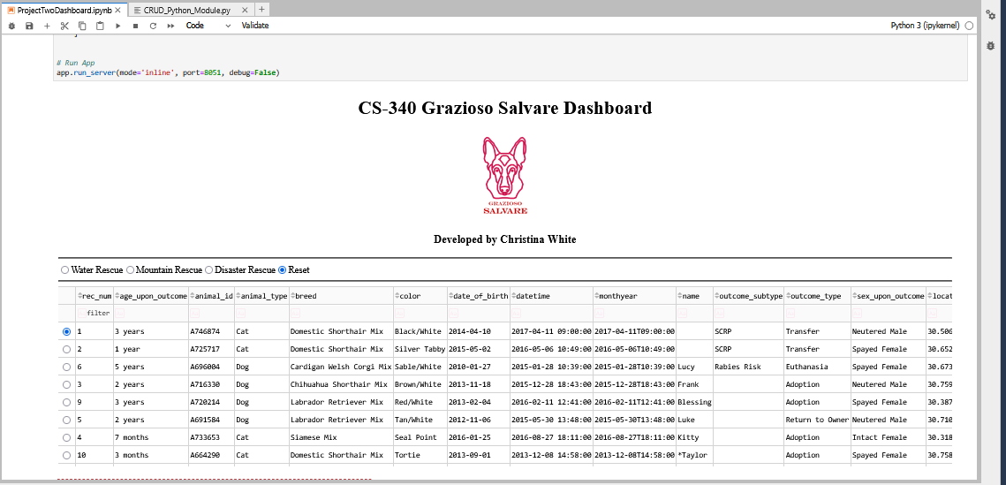
Dashboard/Reset

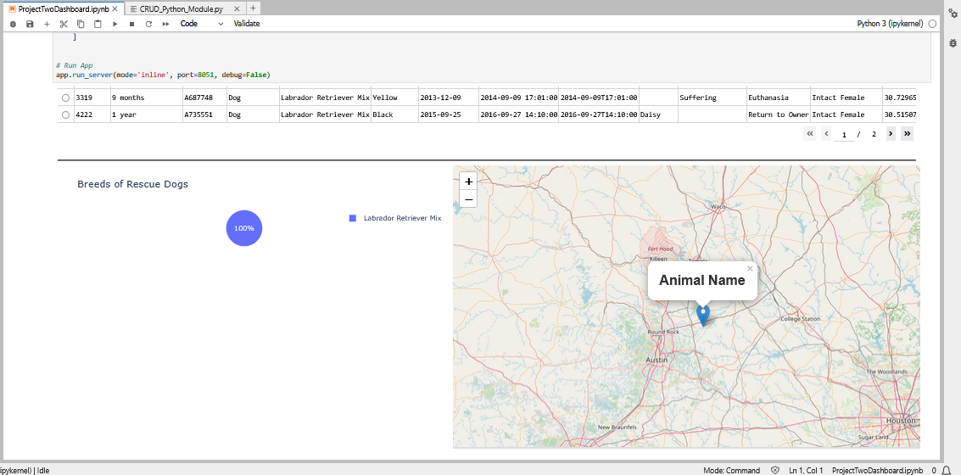
Water Rescue
Disaster Resuce
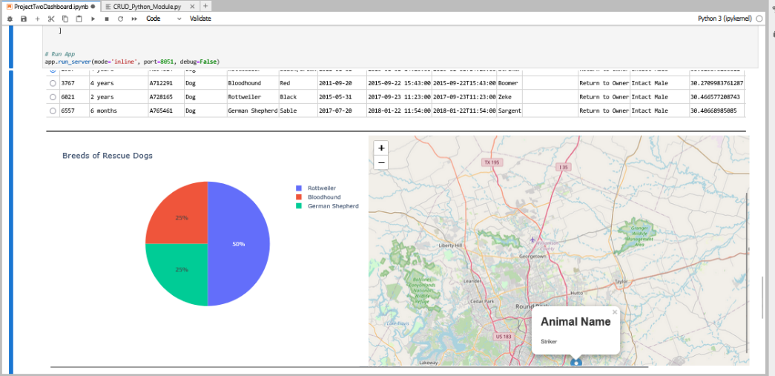
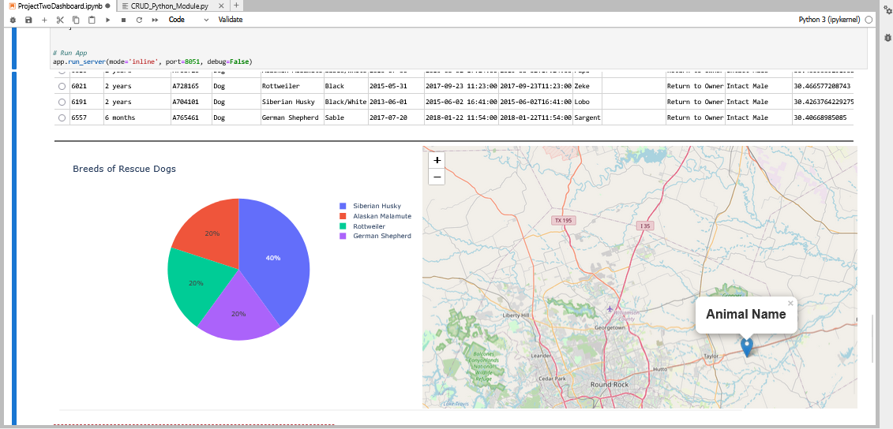
Mountain Rescue

README

Project Overview
This Grazioso Salvare is an interactive web-based application dashboard that filters animal shelter data. This allows users to be able to filter different types of breeds and recuse types such as water, mountain and disaster that help display the available information from the Austin Animal Center.

Tools Used
Mongo DB
Python
Jupyter Notebook
PyMongo
Plotly
The Dash was the chosen framework because it seamlessly integrates the python and helps create the web application without using JavaScript, having reusable UI components for efficient development and has real-time updates to help make sure that the code run smoothly.

Steps
- Installing the MongoDB
- Creating the CRUD Module
- Importing and Verifying documentation and datasets
- Creating the dashboard and layout design
- Testing the code

Challenges
Authentication errors: the application wouldn’t run if the mode and port weren’t clarified.
Indentions: having to start over and re-write the code to match the indents.
Chart Visualization: geolocation chart failed to display correctly causing making the code work.
Real-time Updating: dashboard and kernel were busy, and the code wouldn’t immediately start.

Solutions
Authentication: Making sure that the CRUD module matches the necessary code for it to run.
Indentions: Taking my time and not using the tab button because it messes up the code.
Chart Visualization: Add the data validation before making the chart.
Real-Time Updating: Implementing efficient structures and limiting return fields.

